

HUMAN BIOLOGICAL SCIENCE

STAGE 2 SAMPLE EXAMINATION

Section 7 of the New WACE Manual: General Information 2006–2009 outlines the policy on WACE examinations.

Further information about the WACE Examinations policy can be accessed from the Curriculum Council website at http://newwace.curriculum.wa.edu.au/pages/about_wace_manual.asp.

The purpose for providing a sample examination is to provide teachers with an example of how the course will be examined. Further finetuning will be made to this sample in 2008 by the examination panel following consultation with teachers, measurement specialists and advice from the Assessment, Review and Moderation (ARM) panel.

0000.doc



Western Australian Certificate of Education, Sample External Examination

Question/Answer Booklet

HUMAN BIOLOGICAL SCIENCE
Please place your student identification label in this box
WRITTEN PAPER
STAGE 2

Student Number: In figures

In words

Time allowed for this paper
Reading time before commencing work: 10 minutes
Working time for paper: Three hours

Materials required/recommended for this paper

To be provided by the supervisor
This question/Answer Booklet

To be provided by the candidate
Standard items: Pens, pencils, eraser or correction fluid, ruler, highlighter

Important note to candidates
No other items may be taken into the examination room. It is your responsibility to ensure that you do not have any unauthorised notes or other items of a non-personal nature in the examination room. If you have any unauthorised material with you, hand it to the supervisor before reading any further.

Structure of this paper

Section |  | Suggested working time (minutes) | No. of questions available | No. of questions to be attempted | Marks available
1 | Multiple Choice | 30 | 30 | ALL | 60
2 | Short Answer Questions | 100 | 10 | ALL | 100
3 | Extended Answer Questions | 50 | 4 | 2 | 20  20
 |  |  |  | Total marks | 200

Instructions to candidates

- Please ensure you attach your student identification label in the box on page 1, as well as write your student number in the spaces provided.

- The rules for the conduct of Curriculum Council examinations are detailed in the Student Information Handbook. Sitting this examination implies that you agree to abide by these rules.

- Please ensure you attach your student identification label in the box on page 1, as well as write your student number in the spaces provided.

- The rules for the conduct of Curriculum Council examinations are detailed in the Student Information Handbook. Sitting this examination implies that you agree to abide by these rules.

Section One Answer all questions, using a 2B, B or HB pencil, on a separate Multiple Choice Answer Sheet. DO not use a ball point or ink pen.

Section Two Answer in the spaces provided in this Question/Answer Booklet. DO not answer this section in the section in the Standard Answer Book. A blue or black ball point or ink pen should be used.

Section Three Write your answers in the Standard Answer Book. Your writing or printing must be LEGIBLE. Use a blue or black ball point pen (not pencil) for this section.

- Answers may be presented in a combination of different ways provided they communicate your ideas effectively. You may choose to :
  - Present a clearly labelled diagram
  - Write notes besides a clear diagram
  - Write lists of points, with sentences that link them
  - Write concisely worded sentences
  - Use some other appropriate way to present ideas

- At the end of the examination your Question/Answer Booklet should be attached to the front of the Standard Answer Book/s with the paper binder provided.

SECTION ONE—MULTIPLE CHOICE [60 marks]
Mark your answers to Questions 1–30 on the SEPARATE MULTIPLE CHOICE ANSWER SHEET, using a 2B, B or HB pencil.

SELECT THE CORRECT ALTERNATIVE IN EACH OF THE FOLLOWING QUESTIONS.

Question 1
Which of the following lists has an anabolic process followed by a catabolic process?

 | Anabolic process | Catabolic process
(a) | Respiration | Protein synthesis
(b) | Protein synthesis | Fat digestion
(c) | Anaerobic respiration | DNA replication
(d) | Anaerobic respiration | Aerobic respiration

Question 2
Which relationship listed below is correct?
  - Mitochondria release energy for cell transport
  - Ribosomes break down materials imported by the cell
  - The endoplasmic reticulum packages materials for export from the cell
  - The Golgi body is the site of protein synthesis by the cell.

Question 3
Which event ensures that mitosis produces identical numbers of daughter cells ?
(a) the formation of spindle fibres
(b) the replication of DNA
(c) the movements of chromosomes to opposite poles
(d) the centromere formation

Question 4
Which of the following play an important role in the clotting of blood?
  - leukocytes
  - platelets
  - erythrocytes
  - lymphocytes.

Question 5
Which of the following statements about cell division is correct?
  - Mitosis produces a diploid number of cells while meiosis produces a haploid number.
  - Mitosis takes place in all body cells while meiosis only takes place in gametes.
  - Mitotic division produces cells that differ genetically from one another, while cells formed from meiosis are genetically identical.
  - Meiosis only begins at puberty while mitosis occurs all the time.

Question 6
Metabolism can be described as:

(a) the sum of all chemical reactions in the body
(b) anabolic reactions that produce energy
(c) anaerobic and aerobic respiration
(d) catabolic reactions that release energy.

The diagram of the heart shows the major arteries and veins

For copyright reasons this image cannot be reproduced in the online version of this document.

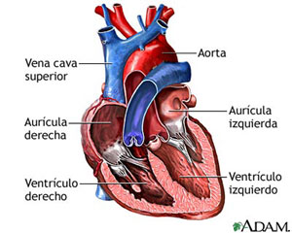
1
2
3
4
5
7
6
8

[Diagram adapted from: A.D.A.M., n.d.]

Question 7
The parts of the heart are correctly identified as:
  - 3 = atrio-ventricular valve 5 = left ventricle 8 = aorta
  - 1 = aorta 2 = right ventricle 4 = right atrium
  - 6 = atrio-ventricular valve 5 = left ventricle 7 = left atrium
  - 1 = vena cava 3 = semi-lunar valve 4 = right ventricle

Question 8
The right ventricle of the heart pumps:
  - oxygenated blood to the rest of the body
  - deoxygenated blood to the right atrium
  - deoxygenated blood to the lungs
  - oxygenated blood to the right atrium.

Question 9
Which of the following statements describes the human genome?
(a) It is a map of all the genes on the human chromosome.
(b) It is the interaction between human genes and the environment.
(c) It states all the possible genotypes of humans.
(d) It states all the possible phenotypes of humans.

Question 10
During childbirth there are a number of key events:
- dilation of the cervix
- breaking of the waters
- secretion of oxytocin by the posterior pituitary gland
- delivery of the baby
- crowning
- contractions of the uterus
- delivery of the placenta

From the list above, the usual sequence of events is:
(a) 2, 3, 1, 6, 5, 4, 7
(b) 3, 6, 1, 2, 5, 4, 7
(c) 6, 1, 3, 2, 4, 5, 7
(d) 3, 1, 6, 2, 5, 4, 7

Question 11
Which of the following statements concerning the effects of the constituents of cigarette smoke is incorrect?
(a) Nicotine causes addiction to cigarettes.
(b) Carcinogens in tar increase the risk of cancer.
(c) Carbon dioxide decreases blood pressure.
(d) Carbon monoxide decreases the oxygen carrying capacity of blood.

Question 12
Urea is a waste that is excreted from the body. Urea is formed by the process of:
  - glycolysis
  - proteolysis
  - deamination
  - anabolism.

Question 13
Which of the following statements are true?
- All unfavourable alleles will be lost from a population as a result of natural selection.
- Mutations occur to suit a population to any change in the environment.
- Natural selection can only occur when there are mutations that produce variation.

  - None of the statements are true.
  - Only 1 and 2 are true.
  - Only 2 and 3 are true.
  - All of the statements are true.

Question 14
Chemical processes in cells produce wastes which must be constantly removed. Why is it necessary for wastes to be removed from cells?
- Wastes may cause damage to the cell membrane.
- Build up of wastes would cause cells to lose water by osmosis.
- Most waste products of cells are insoluble and would use up the cells’ energy.

(d) Wastes change the balance of chemical substances inhibiting cell processes.

Question 15
15 During meiosis, one or more of the chromosome pairs
(a) may not divide completely resulting in the division stopping
(b) may fail to segregate during cell division which is called non-disjunction.
(c) replicate and produce daughter cells of a diploid number
(d) may mutate and cause cell death.

Question 16
If a person is exposed to radiation it increases their risk of having a child who has a mutation.

Radiation does this by:
(a) changing some of the DNA in a sperm or egg cell
(b) doubling the amount of DNA in sperm and egg cells
(c) allowing proteins to control the expression of some genes

(d) changing recessive alleles to dominant and dominant alleles to recessive.

Question 17

Haemophilia is an inherited disorder controlled by a recessive allele carried on the X chromosome. A normal woman had a haemophiliac son and three normal sons. From this it can be concluded, that with respect to the haemophilia allele:
(a) the father was heterozygous
(b) the father was homozygous normal
(c) the mother was heterozygous
(d) the mother was homozygous normal.

Question 18
The word 'allele' means:
(a) an incompletely dominant gene
(b) autosomal mode of inheritance
(c) a co-dominant gene
(d) an alternative form of a gene.

Question 19
Which of the following statements is incorrect?
  - Mutants are kept at low frequency in the population by natural selection.
  - Ionizing radiation, such as X-rays, increases the mutation of genes in direct proportion to the radiation dosage.
  - Most mutations result in unfavourable characteristics.
  - Changes in a physical characteristic of a population can only come about following the mutation of a gene.

Question 20
Which of the following statements regarding gametes is incorrect?
  - Gametes contain a diploid number of chromosomes.
  - Sperm have a tail to assist in movement while movement of the ovum is assisted by cilia in the oviduct.
  - Spermatogenesis produces four spermatozoa while oogenesis produces one ovum.
  - Spermatogenesis occurs in the seminiferous tubules while oogenesis occurs in the ovaries.

Question 21
The following diagram shows the male and female reproductive systems:

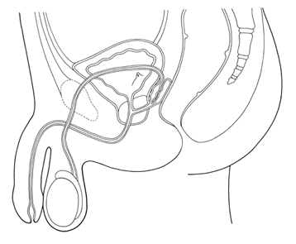
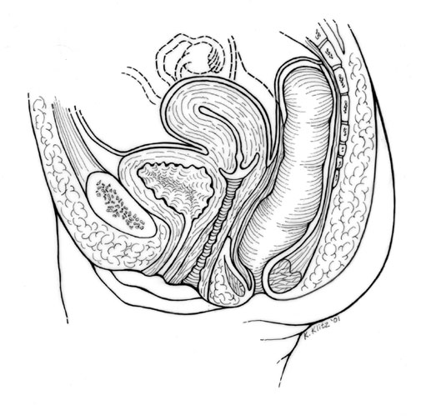
A

B

D

C
F
G
H
I
J
[Diagram adapted from: Klitz, 2001]
[Diagram adapted from: Cull, 1989]

For copyright reasons this image cannot be reproduced in the online version of this document but may be viewed at http://www.meddean.luc.edu/lumen/meded/MEDICINE/PULMONAR/IMAGES/illust1/female_pelvis.jpg

For copyright reasons this image cannot be reproduced in the online version of this document but may be viewed at
http://msjensen.education.umn.edu/webanatomy/image_database/Reproductive/default.htm

Choose from the following alternatives the correctly labelled structures:

(a) | A = testis | D = epididymis | F= prostate gland | G = clitoris | H = cervix
(b) | A = sperm duct | C = testis | G = vagina | I = uterus | J = oviduct
(c) | B = urethra | F = seminal vesicle | G = urethra | H = cervix | I = uterus
(d) | D = epididymis | F = prostate gland | G = labia | H = vagina | J = fallopian tube

Questions 22, 23 and 24 refer to the following information:
As part of a study of human physiology, a scientist used an exercise bicycle and while controlling all other variables, tested a human subject to determine how heart beat changes during exercise and recovery. The data are given in the table below.
In Test A, the subject pedalled at 240 revolutions per minute. He could not continue after 8 minutes and stopped, feeling totally exhausted.
In Test B, after resting for an hour, the same subject then pedalled the cycle at 100 revolutions per minute until he was stopped after 20 minutes, despite feeling able to continue.

TEST A [240 cycles/min] |  |  | TEST B [100 cycles/min]
 | Time [minutes] | Heart rate  [beats per minute] |  | Time [minutes] | Heart rate  [beats per minute]
At rest | 0 | 78 | At rest | 0 | 78
Cycling | 2 | 150 | Cycling | 2 | 146
Cycling | 4 | 164 | Cycling | 4 | 158
Cycling | 6 | 174 | Cycling | 6 | 162
Cycling | 8 | 178 | Cycling | 8 | 164
Recovery | 10 | 180 | Cycling | 10 | 165
Recovery | 12 | 176 | Cycling | 12 | 168
Recovery | 14 | 172 | Cycling | 14 | 172
Recovery | 16 | 168 | Cycling | 16 | 174
Recovery | 18 | 162 | Cycling | 18 | 176
Recovery | 20 | 156 | Cycling | 20 | 176
Recovery | 22 | 150 | Recovery | 22 | 120
Recovery | 24 | 142 | Recovery | 24 | 104
Recovery | 26 | 134 | Recovery | 26 | 100
Recovery | 28 | 124 | Recovery | 28 | 96
Recovery | 30 | 102 | Recovery | 30 | 93
Recovery | 32 | 80 | Recovery | 32 | 85
Recovery | 34 | 78 | Recovery | 34 | 78
Recovery | 36 | 78 | Recovery | 36 | 78

Question 22
In terms of chemical reactions taking place within the subject’s muscle cells, the most accurate explanation for not being able to continue beyond 8 minutes in Test A while he was able to continue cycling for 20 minutes in Test B is
  - In Test A the subject relied on anaerobic respiration for energy.
  - In Test B the subject relied on anaerobic respiration for energy.
  - In Test B the subject relied on the partial breakdown of glucose.
  - In Test A the subject relied on the complete breakdown of glucose.

Question 23
In the experiment which of the following would improve the reliability of results?
i Measure heart rate more accurately.
ii Increase the number of subjects from one to ten.
iii Repeat the experiment ten times.
iv Measure body temperature as well as heart rate.

  - i only
  - i, ii and iii only
  - ii and iii only
  - i, ii, iii and iv
Question 24
In a cell the reactions of aerobic respiration occur in the
  - cytoplasm and release ADP
  - mitochondria and release carbon dioxide, water and ATP
  - cytoplasm and release 36 molecules of ATP
  - mitochondria and require 36 molecules of ATP.

Question 25
A developing embryo has three primary germ layers: the endoderm, ectoderm and mesoderm. Skeletal muscle and bone develops from the
  - mesoderm
  - endoderm
  - ectoderm
  - mesoderm and endoderm.

Question 26
A child displays the ability to crawl, to sit upright with support, to make sounds without meaning and is able to hold small objects. The age of the child is most likely
  - 0–3 months
  - 6–9 months
  - 12–18 months
  - 18–24 months

Question 27
A child who is breast fed receives

(a) Antibodies that protect the child for all of its life
(b) Anitbodies that provide protection for the first few months of life
(c) Antigens that protect the child for all of its life
(d) Antigens that provide protection for the first few months of life

Question 28
The sex of a human embryo is determined by:
  - The presence or absence of an X chromosome.
  - The presence or absence of a Y chromosome.
  - Autosomal chromosomes.
  - The level of hormones produced by the sex organs.

Question 29
Chromosomes from the cells of an embryo taken during amniocentesis testing were prepared and displayed in a photograph called a karyotype. The karyotype is shown in the diagram below.
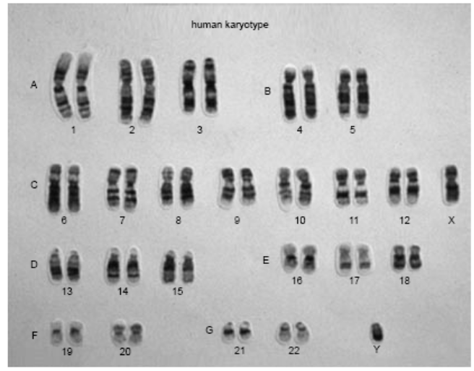
Karyotype
of foetus

[From: Victorian Curriculum and Assessment Authority, 2003]

The karyotype above is most likely that of a
(a) normal male
(b) male with Down Syndrome
(c) normal female
(d) female with Down Syndrome.

Question 30
Which of the following processes allows for sugar to move across a cell membrane?
(a) osmosis
(b) phagocytosis
(c) diffusion
(d) endocytosis.

END OF SECTION ONE

SECTION TWO—SHORT ANSWER [100 marks]
Answer ALL questions in Section 2. Answer in the spaces provided.

Question 31
Three groups of students, A, B, and C, carried out an experiment to investigate the effect of temperature on the action of the enzyme sucrase. Sucrase breaks down cane sugar (sucrose).
Each group of students set up seven test tubes. Each test tube was kept at a different temperature. The time taken for the sucrose to break down completely was recorded and the results from the three groups were averaged.
The results of the experiment are shown in the table below:
Test-tube | Temperature  [°C] | Time taken for sucrose to break down completely  [minutes]
Test-tube | Temperature  [°C] | Group A | Group B | Group C | Average
1 | 0 | 49 | 53 | 51 | 51.0
2 | 10 | 15 | 14 | 16 | 15.0
3 | 20 | 10 | 6 | 9 | 8.3
4 | 30 | 4 | 5 | 4 | 4.3
5 | 40 | 4 | 7 | 6 | 5.7
6 | 50 | 26 | 30 | 28 | 28.0
7 | 60 | 90 | 140 | 100 | 110.0

(a) Graph the average results to best show the relationship investigated. [6 marks]

(b) State one hypothesis that this experiment may have been designed to test. [2 marks]

(c) State the independent variable in your hypothesis. [1 mark]

(d) State the dependent variable in your hypothesis. [1 mark]

(e) State why a well-designed experiment has only one independent variable. [2 marks]

(f) Identify two variables that must be controlled in this experiment. [2 marks]

(g) State how you would control two of these variables. [2 marks]

(h) What is the advantage of calculating an average? [1 mark]

(i) Using your understanding of enzyme controlled reactions, explain why the
enzyme sucrase has no effect on milk sugar (lactose). [2 marks]

- Pancreatic lipase is another enzyme that plays an important role in digestion.
Describe where it is produced and the role it plays. [2 marks]

Question 32
An artificial cell (Fig.1), made from a semi-permeable membrane and filled with a water solution, was placed in a beaker containing a different solution. The membrane is permeable to water and the smaller sugar molecules, glucose and fructose, but is impermeable to the disaccharide, sucrose.

Environment
0.01M sucrose
0.01M glucose
0.01M fructose
The Cell
0.03M sucrose
0.02M glucose
0.00M fructose
Fig.1

- Which solute/s will show net diffusion into the cell? [1 mark]

- Which solute/s will show net diffusion out of the cell? [1 mark]

- In which direction will there be a net movement of water and what effect will that have
on the size of the artificial cell? [2 marks]

Question 33
[Adapted from: Tasmanian Qualifications Authority, 2004]

Use the information shown in the following diagram to help answer the questions below.

Fig.2 Model showing DNA structure

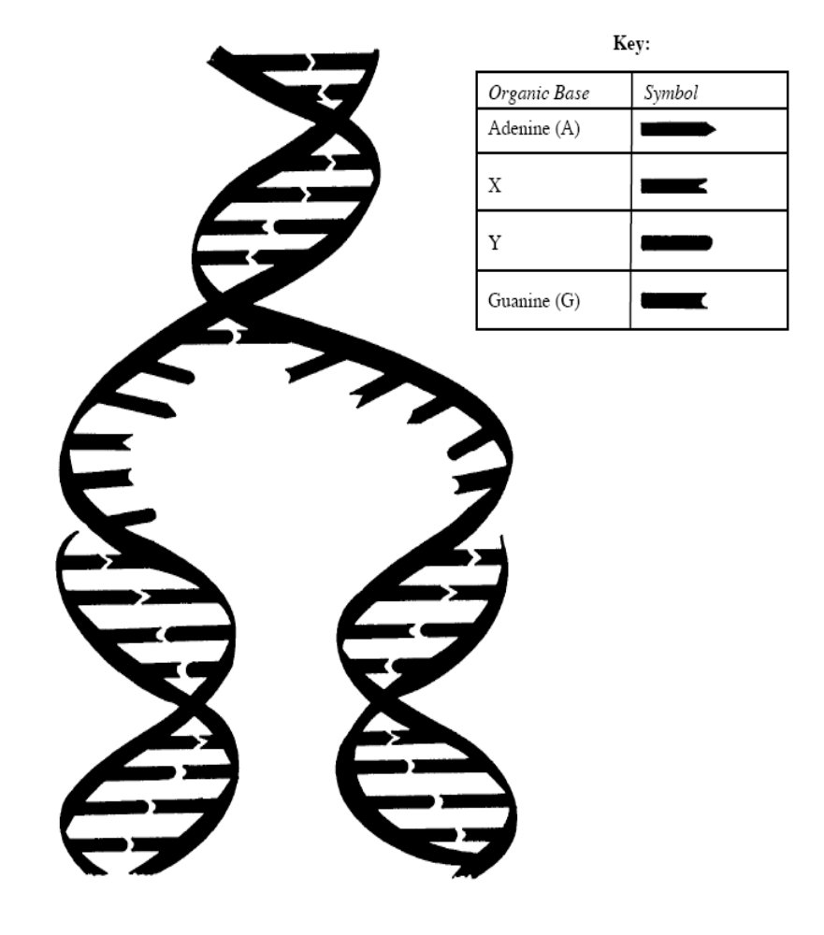

- Identify the bases X and Y.

X :
[1 mark]

Y :
[1 mark]

- Name the process shown in the diagram. [1 mark]

- Explain what is happening in the diagram of DNA. [3 marks]

- Explain why the process shown in the diagram is important. [2 marks]

- Explain how the sequence of bases on a DNA strand is important to a cell’s functioning.
[3 marks]

Question 34
Fig 3. Structure of the respiratory system
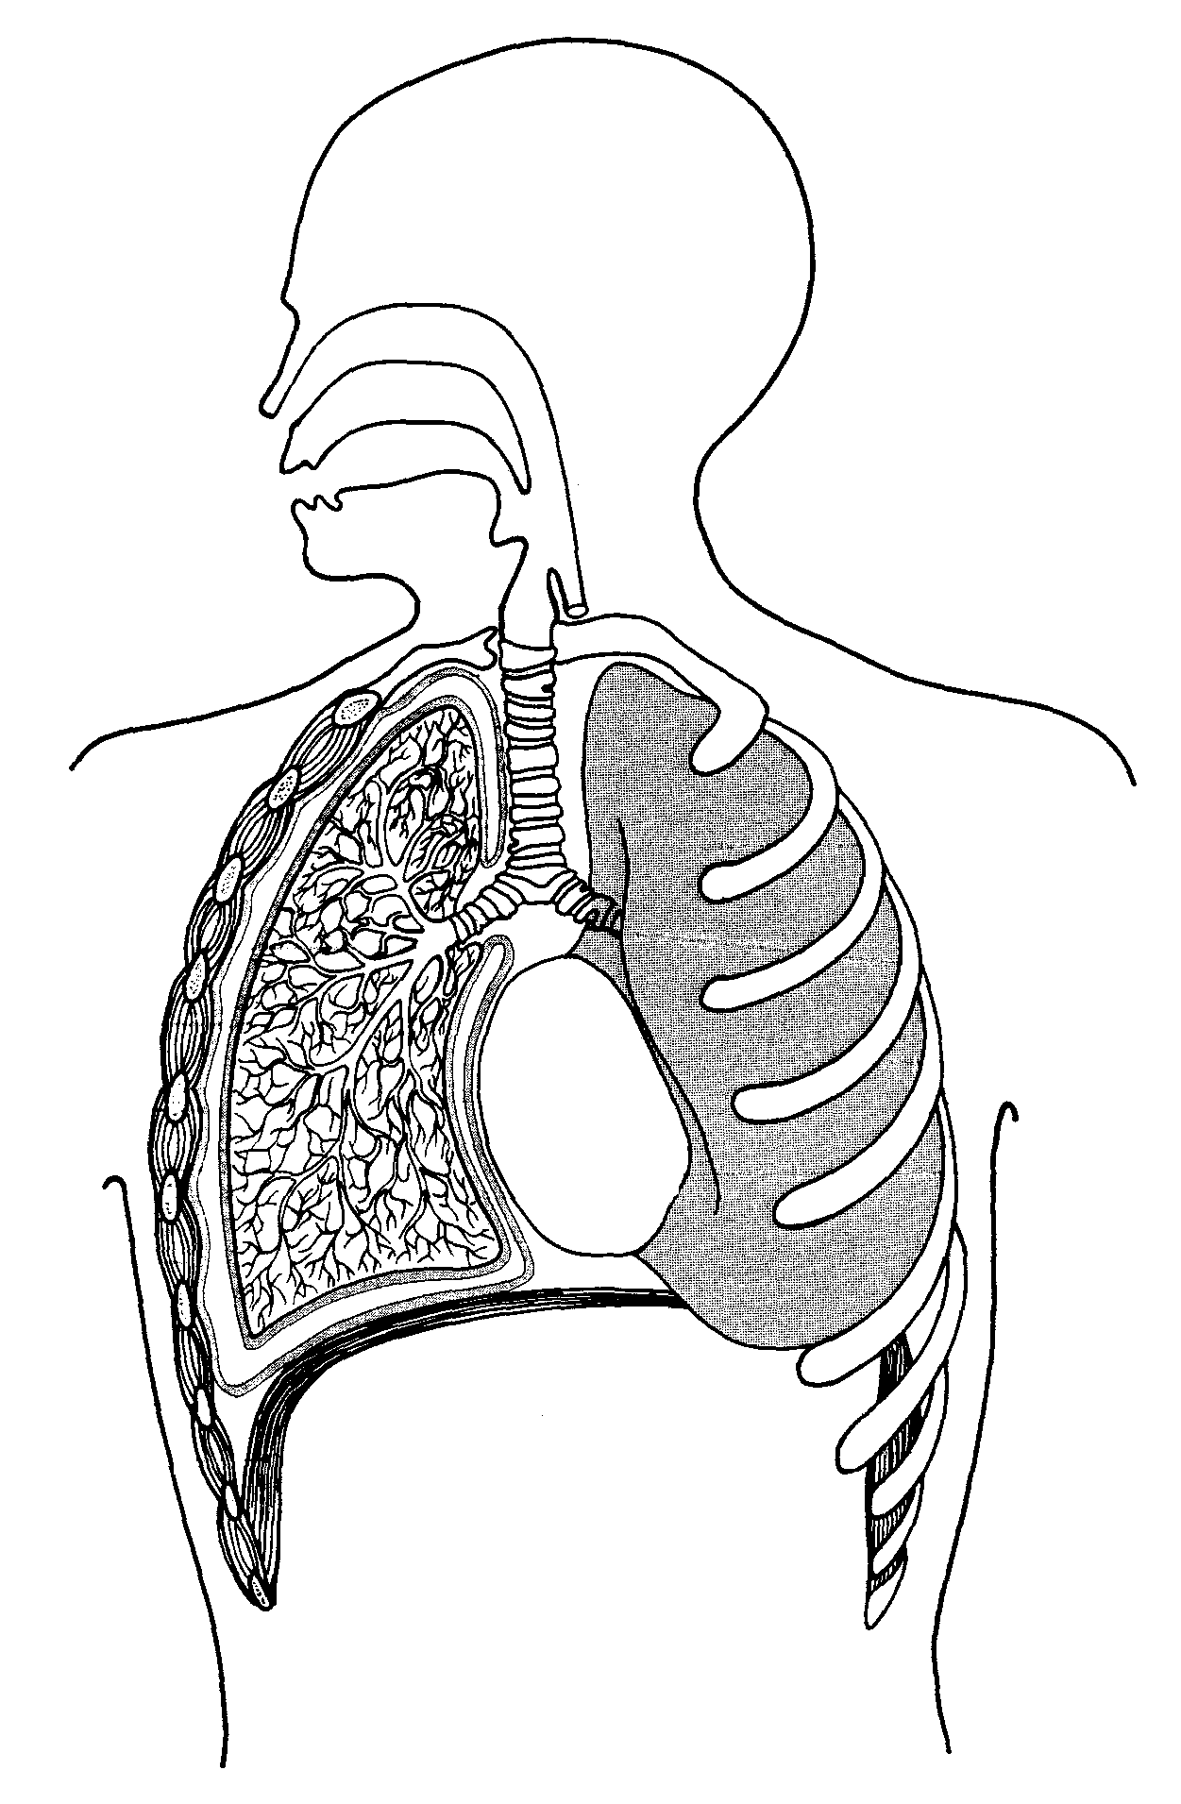
1
2

For copyright reasons this image cannot be reproduced in the online version of this document.

[From: Tudor & Tudor, 1983]

(a) Name features 1 and 2 and explain how they are suited to the function they perform.
[4 marks]

1

2

(b) Explain how the process of inspiration occurs. [4 marks]

(c) People who smoke cigarettes are risking major damage to their health.
Name 2 structures of the respiratory system that suffer damage from cigarette smoking and explain how this damage can impact on the ventilatory process. [4 marks]

Question 35
Fig. 4 The following diagrams show structures of the human digestive system
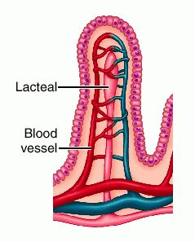
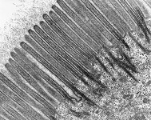
1.
3.
Villus
[Adapted from: Dorland, 2007]
[Adapted from: Jastrow, n.d.]
2.
Highly magnified border of one epithelial cell

For copyright reasons this image cannot be reproduced in the online version of this document but may be viewed at http://medical-dictionary.thefreedictionary.com/_/viewer.aspx?path=dorland&name=villus_villi-intestinales.jpg
For copyright reasons this image cannot be reproduced in the online version of this document but may be viewed at http://www.uni-mainz.de/FB/Medizin/Anatomie/workshop/EM/externes/Wartenberg/Mvilli5E.html

(a) Name and describe the role of structures 1, 2 and 3 in the absorption of digested food substances in the small intestine. [6 marks]

1

2

3

(b) Describe the role of bile in digestion. [2 marks]

Question 36
Fig. 5
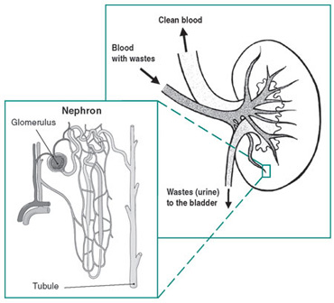

B _________
A _________
C _________
[Adapted from: National Kidney and Urologic Diseases Information Clearinghouse, n.d.]

For copyright reasons this image cannot be reproduced in the online version of this document but may be viewed at
http://kidney.niddk.nih.gov/kudiseases/pubs/yourkidneys/#1
Refer to Fig. 5 to answer the following:

(a) Name Structure A ____________________________________________ [1 mark]

Name Structure B ____________________________________________ [1 mark]

(b) What is the function of Structure B? [1 mark]

(c) List the main components that make up urine (C). [3 marks]

Question 37
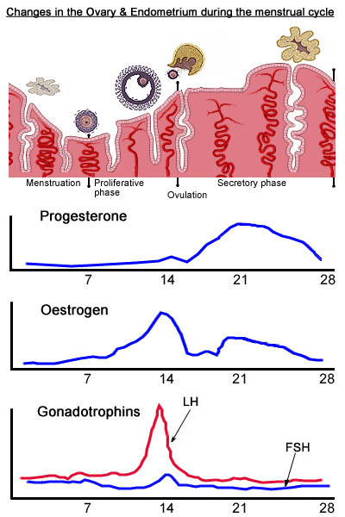
The following chart (Fig.6) shows changes in female hormone levels during a 28 day period. Refer to this chart in order to answer the questions which follow.
Wall of tubule

D
7 14 21 28
A
B
Hormone W
Hormone X
Hormone Y
Hormone Z
Days of cycle
C
1
1
1
1
17 14 2128

For copyright reasons this image cannot be reproduced in the online version of this document.

Fig. 6

[Adapted from: St George’s University of London, n.d.]

(a) Identify hormone Y and describe the role it plays in the cycle. [2 marks]

(b) On or around Day 14, what change occurs in the ovary? [1 mark]

(c) Identify hormone W and describe the role it plays in the cycle? [2 marks]

Question 38
This question is based on the following diagram of a human placenta
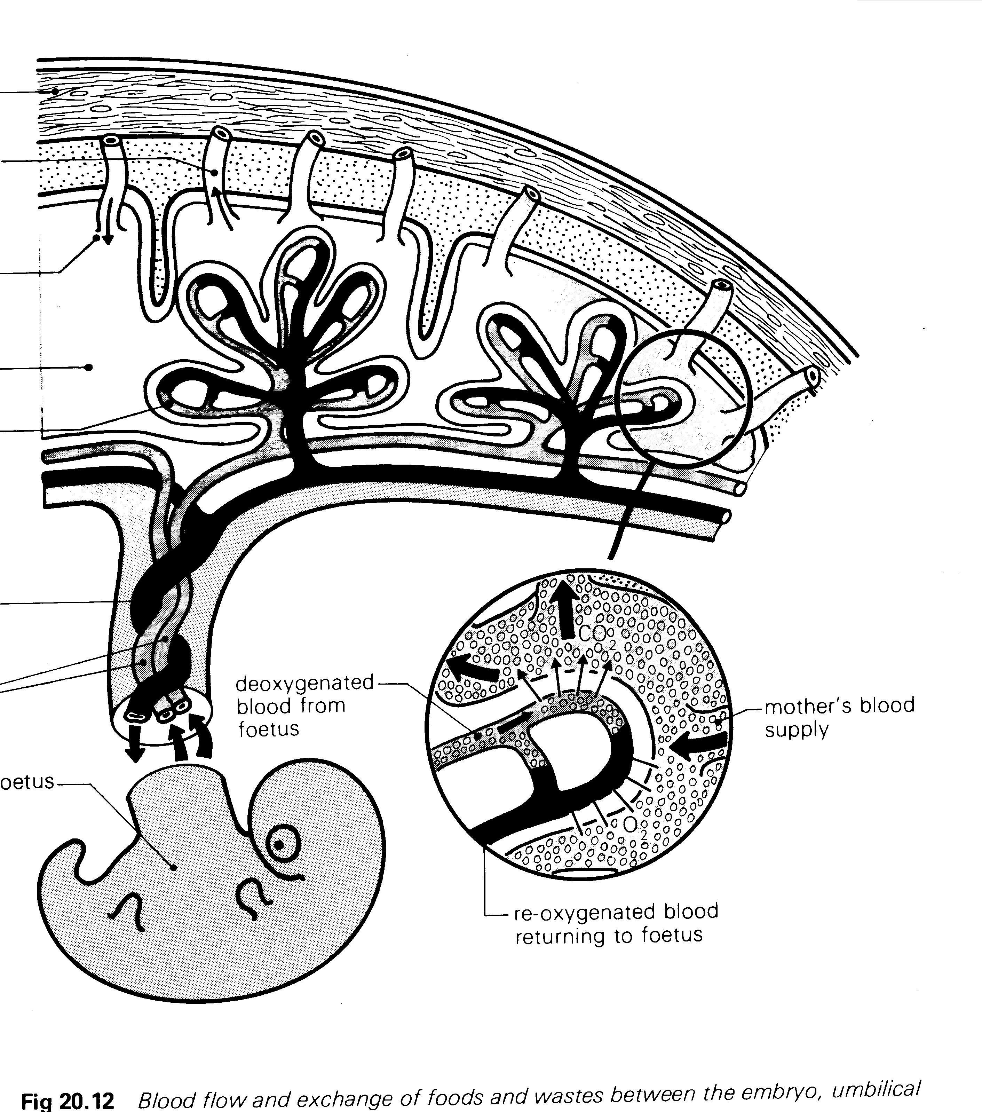
Muscle of uterine wall
Vein leading from blood filled cavity (sinus)
Artery leading to blood
filled cavity (sinus)
Maternal blood sinus
Villus of the placenta
Vein in umbilical cord
Arteries in umbilical cord
foetus
.
.
.
.
.
.
.
.

For copyright reasons this image cannot be reproduced in the online version of this document.

[Adapted from: Newton, & Joyce, c1995]

(a) Explain three ways the placenta allows efficient exchange of materials between the mother and the foetus. [6marks]

(b) Describe two differences between the circulatory system of a foetus and that of a baby.
[4 marks]

(c) What is a teratogen? [2 marks]

(d) Give an example of a teratogen and describe the effects of this teratogen on an
unborn child. [2 marks]

Question 39
(a) What are stem cells? [2 marks]

(b) What is the difference between adult and embryonic stem cells? [2 marks]

(c) Describe two possible uses of stem cells. [4 marks]

(d) Explain one of the controversial issues related to the proposed use of stem cells.
[2 marks]

Question 40
The following pedigree was drawn for a family in which individuals had a rare genetically determined condition.
The individuals with the condition are shown as black squares or circles. This condition was unknown in previous generations of this family.

1 2
3 4 5 6 7 8 9 10 11
12 13 14 15 16 17 18 19 20 21 22 23
24 25 26 27 28

- Determine if this autosomal condition is dominant or recessive. Give reasons for your
answer. [2 marks]

- Using the symbols ‘H’ and ‘h’ write all the possible genotypes of individuals [3 marks]

1 ___________________________________________

8 ___________________________________________

13 ___________________________________________

(c) What evidence in the pedigree confirms that the condition is not sex linked? [3 marks]

END OF SECTION TWO

SECTION THREE—EXTENDED ANSWER [40 marks]

Choose TWO of the following four extended answer questions.
Each question is worth 20 marks.

Question 41
The skin is one way the body is able to prevent the entry of pathogens.

- Describe three other ways that prevent the entry of harmful organisms.
[6 marks]

- If a splinter breaks through our skin, an inflammatory response may occur. Describe this response. [8 marks]

- Should bacteria spread away from the area of the splinter they might enter the lymphatic system. Describe the role of the lymphatic system in preventing the further spread of infection. [6 marks]

Question 42
The circulatory system plays a vital role in our bodies.

- Arteries veins and capillaries are blood vessels. Describe three structural features of each. [9 marks]

- Explain how one of the structural features you have described for each of the types of blood vessels helps these blood vessels to carry out their function. [6 marks]

- Describe how the circulatory system transports gases around the human body. [5 marks]

Question 43
In our society it is becoming increasingly common for couples to have children at a much older age. One consequence of this delay in parenthood has been that older couples may find it more difficult to become pregnant.

- To avoid pregnancy in earlier years, couples may choose to use various forms of contraception. Describe three methods of contraception that could be used to prevent the sperm reaching the ovum. [6 marks]

- Describe two problems that may lead to couples having difficulty conceiving and explain the technology available to people having these difficulties. [8 marks]

- Discuss three ethical issues that may arise as a result of the use of these technologies. [6 marks]

Question 44
Mutations occur in a variety of ways and lead to variation in populations.

- Define the term mutation, name the two types of mutations and explain each type. Give an example of each type of mutation and explain how each affects the human body. [8 marks]

- Mutations are one way that variation occurs. Describe some of the other sources of variation that may be caused during meiosis. [6 marks]

- Discuss some examples of genetic technology that are available to test for gene abnormalities. [6 marks]

Circle the TWO questions you have chosen to answer: Questions 41 / 42 / 43 / 44

END OF EXAM

ACKNOWLEDGEMENTS

SECTION ONE

Question 6: Diagram adapted from: A.D.A.M. (n.d.). [Diagram of heart]. Retrieved July, 2007, from Georgetown University website: http://lumen.georgetown.edu/faulty/che3/bvl/images/heartChambers2.jpg.

Question 21: Diagram 1
Adapted from: Cull, P. (Ed.). (1989). The sourcebook of medical illustration. Carnforth, UK: Parthenon Publishing Group. Retrieved July 2007, from University of Minnesota Website: http://msjensen.education.umn.edu/webanatomy/image_database/Reproductive/default.htm.

Diagram 2
Adapted from: Klitz, K. (2001). [Diagram of female reproductive system]. Retrieved July 2007, from Loyola University Chicago, Stritch School of Medicine website: http://www.meddean.luc.edu/lumen/meded/MEDICINE/PULMONAR/IMAGES/illust1/female_pelvis.jpg.

Question 29: Photograph from: Victorian Curriculum and Assessment Authority. (2003). Biology: Written examination 2 (p.2). Retrieved November, 2006, from http://www.vcaa.vic.edu.au/vce/studies/biology/pastexams/2003_biol2.pdf.

SECTION TWO

Question 33: Adapted from: Tasmanian Qualifications Authority. (2004). Tasmanian Certificate of Education: Biology: Senior Secondary 5C: External assessment (pp. 4-5). Retrieved October, 2006, from http://www.tqa.tas.gov.au/4DCGI/_WWW_doc/007022/RND01/BIO5C_paper04.pdf.

Question 34: Image from: Tudor, E.M., & Tudor, E.R. (1983). Understanding the human body (2nd ed.). London: Pitman, p.140, fig.7.5.

Question 35: Image 1
Adapted from: Dorland, W. A. N. (2007). Dorland's illustrated medical dictionary (31st ed.). Philadelphia: W.B. Saunders. Retrieved July, 2007, from The Free Dictionary website: http://medical-dictionary.thefreedictionary.com/_/viewer.aspx?path=dorland&name=villus_villi-intestinales.jpg.

Image 2
Adapted from: Jastrow, H. (n.d.). Electron microscopic atlas of cells, tissues and organs in the internet. Retrieved July, 2007, from Johannes Gutenberg University Mainz website: http://www.uni-mainz.de/FB/Medizin/Anatomie/workshop/EM/externes/Wartenberg/Mvilli5E.html.

Question 36: Images adapted from: National Kidney and Urologic Diseases Information Clearinghouse. (n.d.). Your kidneys and how they work. Retrieved July, 2007, from http://kidney.niddk.nih.gov/kudiseases/pubs/yourkidneys/#1.

Question 37: Image and graphs adapted from: St George’s University of London. (n.d.). Key topics: Menstrual cycle. Retrieved July 2007, from http://www.elu.squl.ac.uk/rehash/example/reproduction_anatomy_physiology/female/menstrualcycle.htm.

Question 38: Diagram adapted from: Newton, T.J., & Joyce, A.P. (c1995). Human perspectives: Book 1 (3rd ed.), Sydney: McGraw-Hill, fig. 20.12.
Published by the Curriculum Council of Western Australia
27 Walters Drive
OSBORNE PARK WA 6017

